ENEE 245 PSpice® Tutorial for Digital Circuits

**This tutorial will show you how to:**

* Use schematic capture to specify a digital circuit design
* Simulate that design in PSpice

PSpice® is a powerful software package that is capable of simulating large, realistic analog as well as digital electronic circuits. In this course, you will use PSpice to simulate the behavior of the first 4-5 lab designs. Full versions of the ORDAC PSpice version 10 (or higher) can be found in the Jasmine Lab (AVW 2446 - http://www.it.umd.edu/Labs/jasmine.htm). This lab maybe sometimes inaccessible because of regularly scheduled classes and special events, but other times are open for use to all students. The hours that the rooms are available are normally posted on the web at http://www.ece.umd.edu/ececf/LabInfo/schedules/current.htm. You need to create an account to use these computers. The appropriate form can be obtained from the ECE Help Desk (AVW 1449A – ecehelp@eng.umd.edu). Fill out the form and turn it in at the Help Desk during the first week of classes, so that you don’t have delays when you need to start your simulations.

Figure 1. A Divide-by-3 Asynchronous Counter

The discussion here emphasizes PSpice features that are important for modeling digital circuits. We shall use as example a divide-by-3 asynchronous counter, which is similar to one of the circuits you will construct in Lab 2. The circuit consists of a clock, a divide-by-4 counter, and reset circuitry, as shown in Fig. 1.

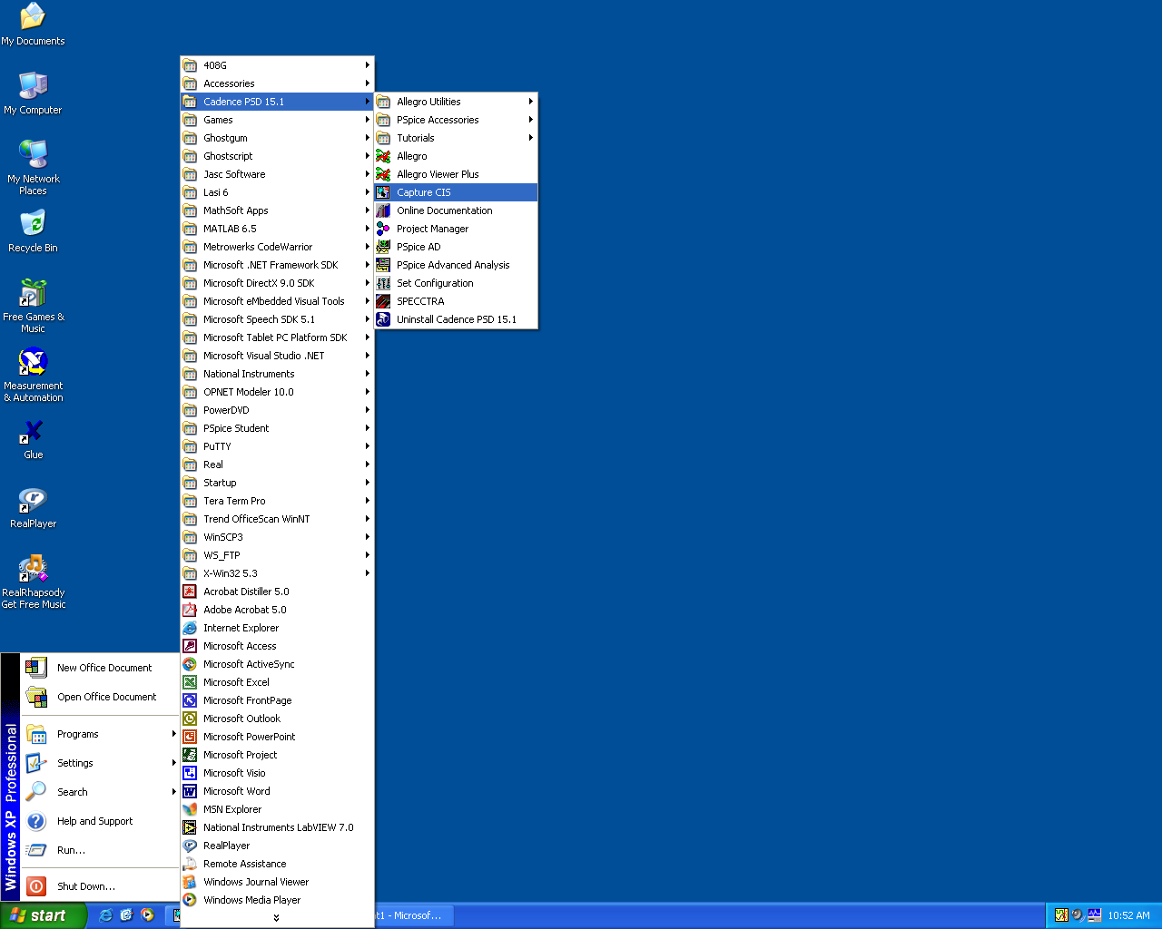Start PSpice by clicking the Windows “Start” button, then “Programs”, then “Cadence PSD 15.1”, and finally “Capture CIS”. In the dialog box that appears, click o.k. for PCB Design Studio with Capture CIS.

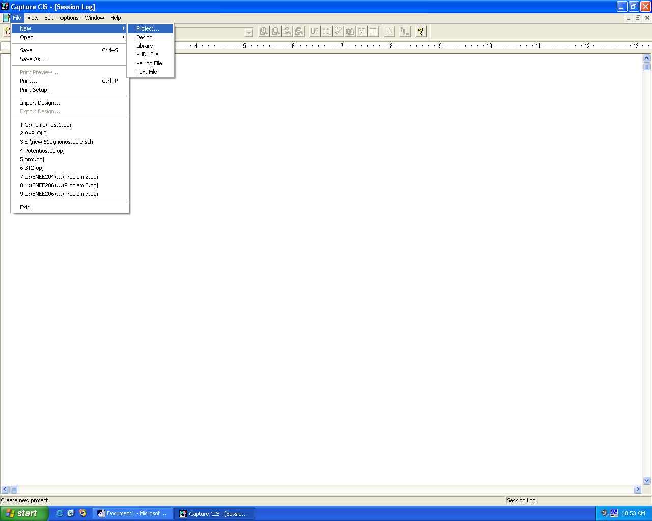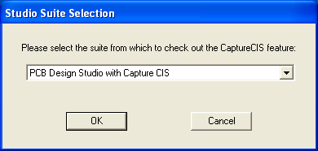**Starting a New Project**

After the program loads, select from the drop-down menu at the top: “File” and then “New” and then “Project…” A “New Project” dialog box will appear. There are three important things to look at before clicking “OK”. First, you must give your project a name. Second, make sure that “Analog or Mixed A/D” is selected (click on the circle to the left if the dot doesn’t indicate this option as shown in the figure). Finally, make sure that the location at the bottom is either the desktop or c:\temp. Change the location with the browse button, or by typing the name in the location box if necessary. In the “Create PSpice Project dialog box, select “Create a blank project”, since this is your first effort.

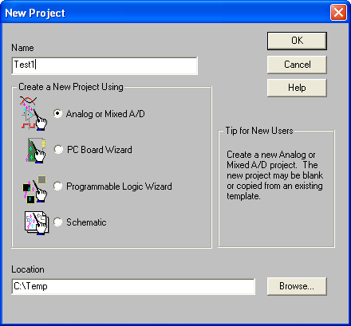

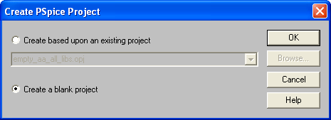

**Creating the Circuit**

We are now ready to start drawing the circuit in the schematic “drawing board” that appears (see next figure). The first thing we need to do is place parts. There are several ways to get the parts we need. Let’s use the drop-down “Place” and then “Part…” options. The “Place Part” dialog box that appears is shown. It is a rather important box, so we’ll discuss it in a little detail. All of the parts, resistors, voltages sources, ICs, etc., have models which detail the properties of these components, and the models are stored in libraries. The same basic part (for example, a digital clock) may have different models in different libraries, and often, these models don’t function the same, so it is always important to know the specific model you are using.

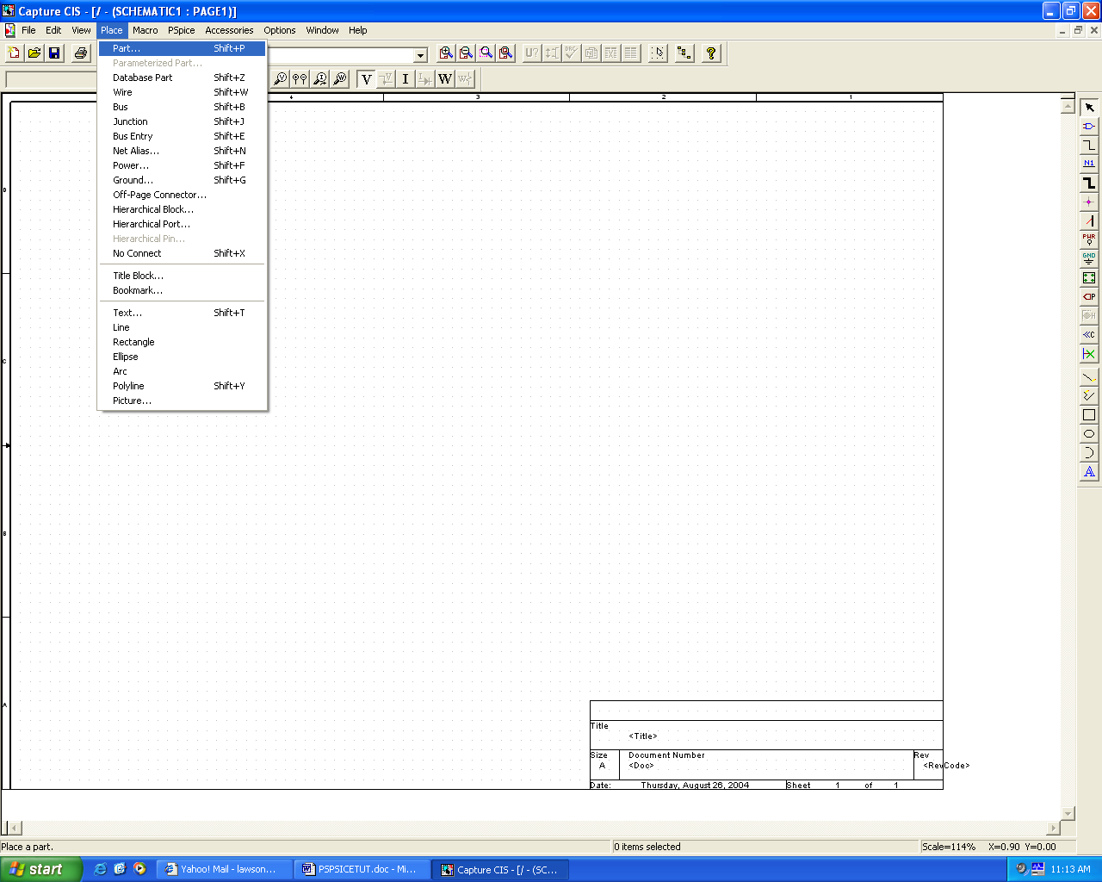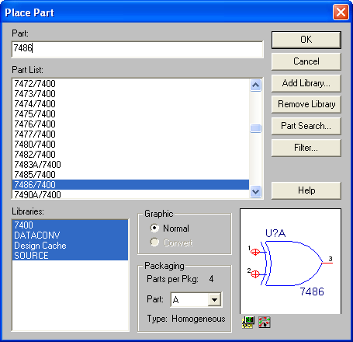

In the dialog box shown above, four libraries are indicated in the box in the lower left corner. The “7400” library has models for most of the TTL chips. The “SOURCE” library has the digital clock, dc source, etc. “Design Cache” has the models that we have already used in this circuit. The libraries that will be searched for parts are highlighted in blue (all of the libraries are highlighted here). If you can’t find a part, you can use the “Part Search…” button if you know the part name. You can add or delete libraries to the list with the buttons shown on the right.

To place an XOR gate, type “7486”. You can see a picture of the part in the lower right-hand box. Packaging details are given just to the left. Because this is the first XOR that you are using (there are four in a package), it will have the name “U1A”. Click the “OK” button to place the XOR in the circuit. Move the mouse to position the part (note that an outline/image of the part is attached to the cursor arrow) and use the left mouse button click to place a 7486. You can use “CTRL-R” to rotate the part by 90 degrees to get the proper orientation before placing the part. Notice that after you place one 7486, the part is still attached to the cursor arrow. Move the cursor and left-click again to place the second 7486. Then click with the right mouse button to get the dialog box shown to the right. Select “End mode” to stop placing 7486s. The cursor arrow will return to normal.

Repeat the “Place” / “Part” / Mouse movement sequence to place the 7432 OR gate and two 7476 JK Flip-flops. Remember to make sure that you are using the model from the 7400 library – in the “Place Part” dialog box, the library name is shown after the part name and “/” in the “Part List” box.

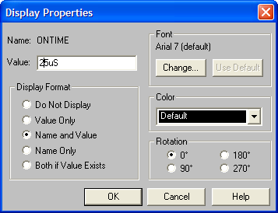The part name for the battery is VDC, so use that in the “Place Part” dialog box. Likewise, the name for the digital clock is “DigClock”. Place both of these parts as indicated in the circuit diagram (Fig. 1). Note that the DigClock has on-times and off-times of 0.25uS (microseconds). We want to have a 50 microsecond period, with a 50% duty cycle, so we need 25 microsecond on (logical 1) / off (logical 0) times. Just double-click on the “on time” label to get the display properties box. Change the on-time value to 25uS and click “OK”. Repeat this procedure for the off-time. Note that the DC battery has a value of 0V. Double-click on the 0V value and change the voltage to 5Vdc in the dialog box that appears. Do not leave a space between the value and the units.

We can place a GROUND via the “Place” and “GROUND” drop-down menus. The part name is “0” in the SOURCE library. Alternatively, you can go to the white box, below the “OPTIONS” drop down menu, and type in “0”. When you move the cursor back to the circuit area, a GROUND will be attached to the cursor arrow. Note that if you click on the down arrow to the left of this white box, a list appears of all the parts that you have used so far. This is the “Design Cache” library list, and you can use the box as an alternate method to place parts.

Next, you can place the wires using the “Place” / “Wire” drop down sequence, or using the “Shift-W” shortcut indicated in the drop-down menu. Move the cursor (which now looks like a “cross hair”) on top of a node and left-click. When you move the mouse again, you will see that a line appears, showing where the wire will go the next time that you left-click. Move the mouse to the node you want to connect and left click. You can continue in this manner – two clicks for every wire – until all of the wires are placed. Some circuits are complicated, and wires need to make several turns, or cross over other wires before they make their connection. You can left-click more than twice to draw just one wire in order to make additional turns if you like. Also, notice that when you are moving the cursor around, often red circles appear. These red circles are always on top of nodes, and they indicate that if you were to left click at that moment, you would be attaching wires to these nodes. Make sure that you route the wires correctly, so that you don’t accidentally make any unwanted connections. After connecting all the parts, your circuit should look more or less like Fig. 1.

The next thing to do is check to make sure the drawing has no obvious connection errors. From the drop-down menus select “PSpice” / “Create Netlist”. If there are no errors, nothing obvious will happen. If they are errors or warnings, a message will appear, and often a green, hollow circle will appear near the source of the error. If you click on the center of that circle, an explanation will appear. If all else fails, go for help.

**Circuit Simulation**

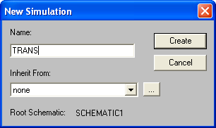We shall simulate this circuit in the time domain, i.e., we will look at the pulses to make sure that we have designed a divide by three counter. Also, we know that this asynchronous counter has glitches, so we want to see one of them. From the drop-down menus pick “PSpice” / “New simulation Profile.” In the dialog box that appears, make the name “TRANS” before clicking “Create”.

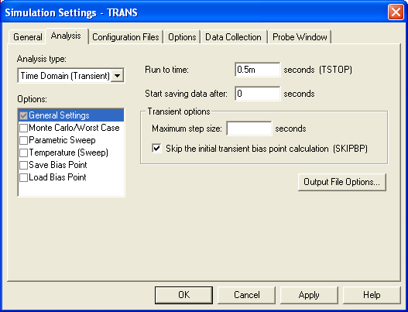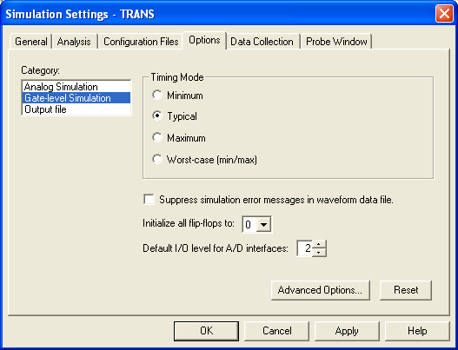The next dialog box that appears is fairly complicated, but we will focus only on what is needed for our simulation. When the analysis tab is selected, choose the analysis type “Time Domain”. Select a run time of 0.5 mS (m is for milli). Click on the box that says “Skip the initial transient bias point calculation” so that the check-mark appears. This will allow all voltages to start up from zero.

Next, you need to click on the “Options” tab. This will bring up the menu shown on the right. Click on “Gate-level Simulation. Change “Initialize all flip-flops to “0”. Normally it is set to “X” – undefined – and the output of the circuit will be ambiguous. Finally, change the “Default I/O level for A/D interfaces to “2”. The reason for this is beyond the scope of this course, but you can read more about it in PSpice books. Basically you are changing the model used at interface nodes between logical signals and analog signals. With Level 1, the simulation may not work at all, or you may receive many “digital simulation warnings”, which indicate that PSpice believes that a race condition or some other problem may exist in your circuit. Other levels may be tried if problems persist. Hit “OK” when all the changes have been made.

Remember to save your work now and then, just in case something unexpected happens.

Now the simulation setup is complete, and it’s time to start the simulation with the “PSpice” drop-down menu followed by “Run”. If there are errors in your circuit connections, PSpice will let you know via error messages at this time and you must fix them before proceeding. If not, the code will open the “Probe” plotting package to help you view the simulation results. If PSpice says that there are “digital simulation warnings,” then PSpice has detected potential race conditions (or other problems) and will allow you to examine these with probe. In this case you will see a “simulation messages” dialog box when “Probe” initiates. Usually you can just click on the “no” button to ignore the warnings. If you push the “yes” button, a list will appear indicating which device had a problem, what type of problem occurred, and when it occurred. If you double-click on a message line you will see a plot that displays the problem and gives you some additional information.

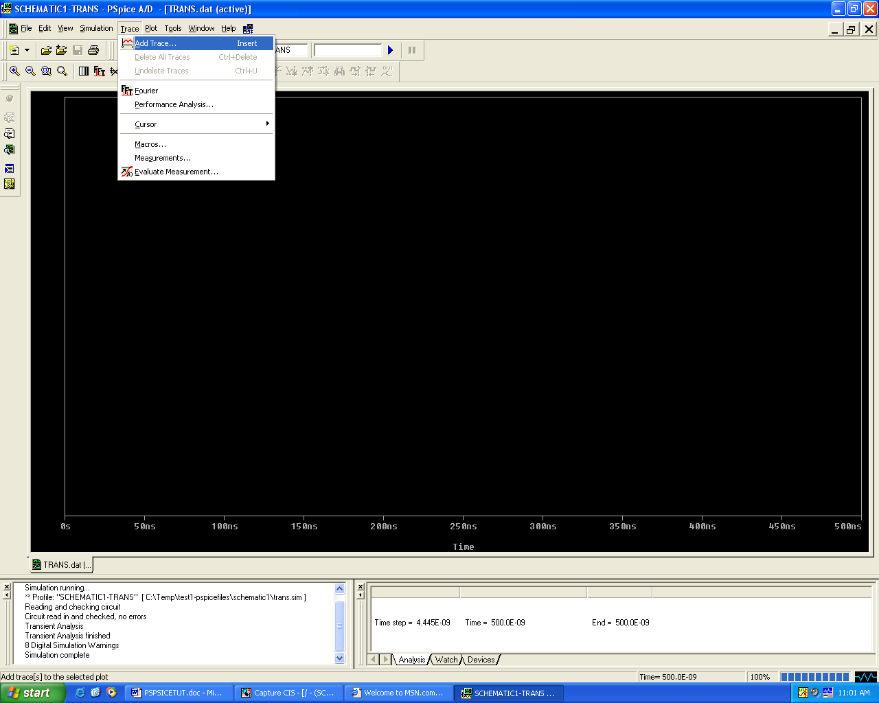When there are no errors in your circuit, you can use Probe to generate the plot shown in Fig. 2a. After you click on “Trace” and “Add”, notice that the “Add Traces” dialog box has a number of options: digital, analog, voltages, currents, alias names, and subcircuit nodes. Make certain that only “digital” and “alias names” are selected. The variables included in the reduced list are the nodes that have state

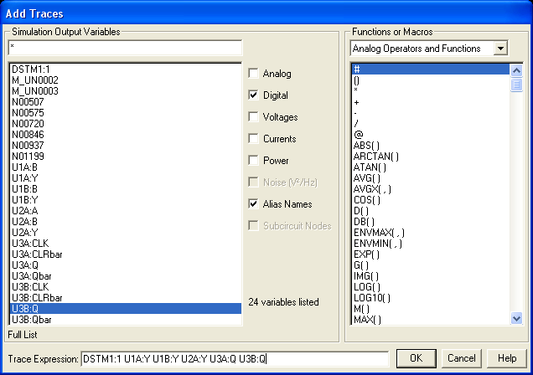

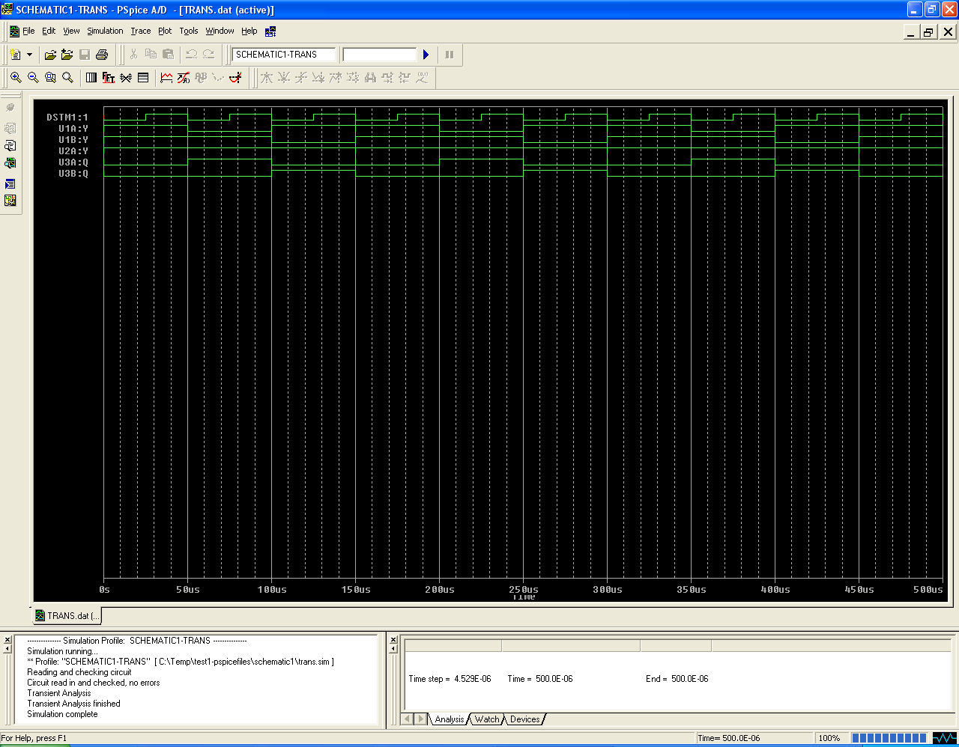

Figure 2a. Probe Output for the Circuit in Fig. 1.

(logical) values which can be plotted. For example, U3A:Q and U3B:Q are the names of the flip-flop output signals, while U1A:Y is one of the XOR gate outputs. Just click on these three values, plus U1B:Y and U2A:Y, and DSTM1:1 (the digital clock). Note that these values appear in the “Trace Expression” line at the bottom. Note also that you could have just typed the names directly on this line, or used the math functions on the right with combinations of variables to make complicated and useful plots. Click “OK” when you are done.

Fig. 2a plots the clock input, the flip-flop outputs, and the outputs of the three logic gates. Note that the counter circuit does cycle through the sequence zero-one-two, but there is a narrow spike before the counter resets to zero.

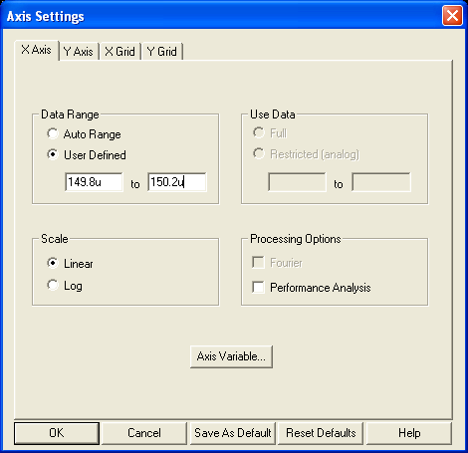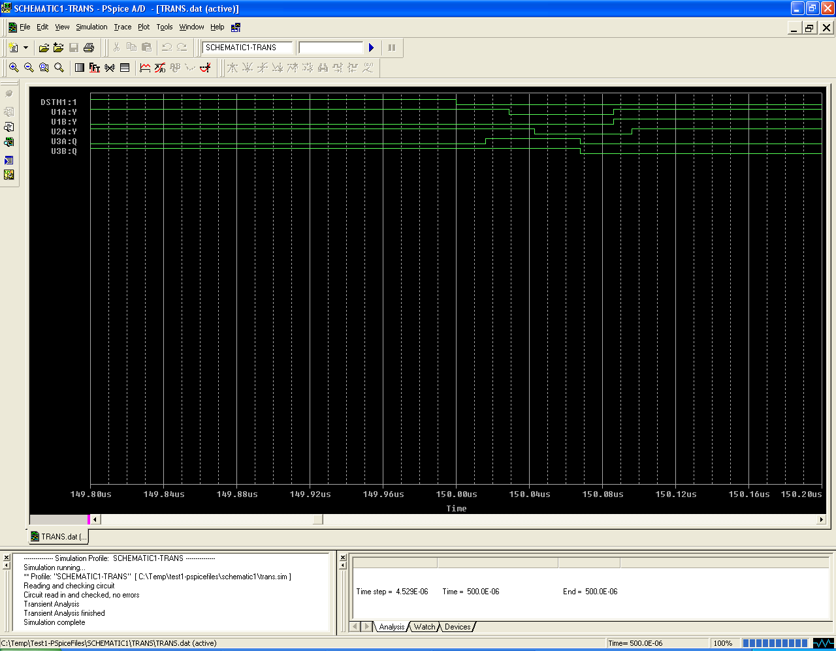You can see the details of this glitch by expanding the scale of the X-axis. Click on the “Plot” drop-down menu, then on “Axis settings”. In the dialog box that appears, make sure the X-axis tab is on top, and change the “Data Range” to “User Refined”. Set the minimum (left-most box) time to 149.8 uS and the maximum time to 150.2 uS. Once the counter output becomes a three, it takes about 25 ns for the flip flops to reset. These delays can be seen in the plot in Fig. 2b. Probe has cursors that can be used to measure these times. In the “Tools” drop-down menu, click on “cursor” and then “display”. Two cursors are available. Cursor “A1” is placed by clicking the left mouse button. It can also be moved by using the left and right arrow keys. The “Probe Cursor” box indicates the time coordinate of the cursor and the logical value of one of the variables (or the voltage or current if it is an analog signal). The logical variable displayed can be changed by moving the mouse on top of one of the variable names (on the left side of the plot) and clicking the left mouse button (a box will appear around the selected variable name). The right mouse button controls the second cursor (A2). Holding the “shift” key down while pressing the arrow keys enables fine-tuning of A2’s position.

Figure 2b. Expansion of the X-axis revealing the “glitch”.

This tutorial has given a brief introduction to the use of PSpice for digital circuits. PSpice has many more powerful features for analyzing circuit performance. There are a large number of books that describe the details of the capabilities and operation of PSpice. You are strongly encouraged to read some of these books and to experiment with different features.